About the Charities

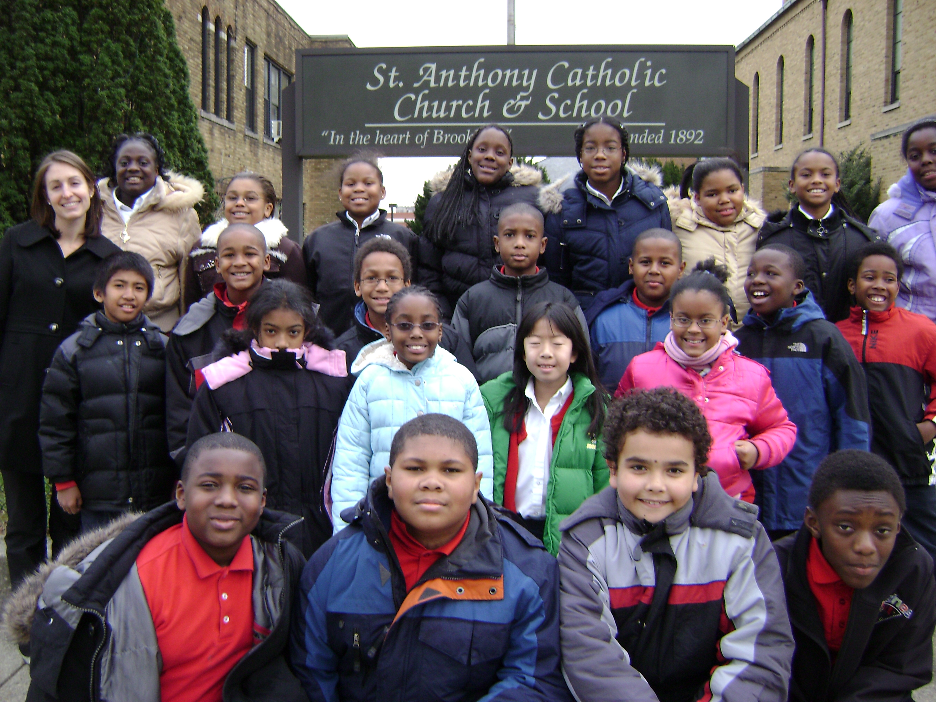
St. Anthony’s

The mission of St. Anthony Catholic School is to prepare its students for lives of service and leadership rooted in the Catholic values of faith, hope, and acceptance.

St. Anthony serves students in Pre-Kindergarten3 thru grade eight. Our students are exposed to the arts, band, computers, library skills, music, physical education, and Spanish. In addition, we offer a variety of extra-curricular clubs, school choir, student council, and a CYO sports program.

Discipline and academic rigor are essential for success and integral to our school’s culture. St. Anthony’s follows the academic standards issued by the Archdiocese of Washington. Well prepared students from St. Anthony Catholic School score well on standardized tests and on the High School Placement Test (HSPT). It is not surprising that 100% of our graduates are accepted into Catholic high schools and public high schools of choice.
St. Anthony families are dynamic in the ways they contribute to our school. They have an active Home and School Association that both raises funds and also works to build

community and enhance existing programs. Lastly, St. Anthony’s has a school-wide service hour program where each family serves twenty hours throughout the year. There are endless opportunities to earn hours: office help, chaperoning, working hot lunch, assisting with the Christmas Concert, etc.

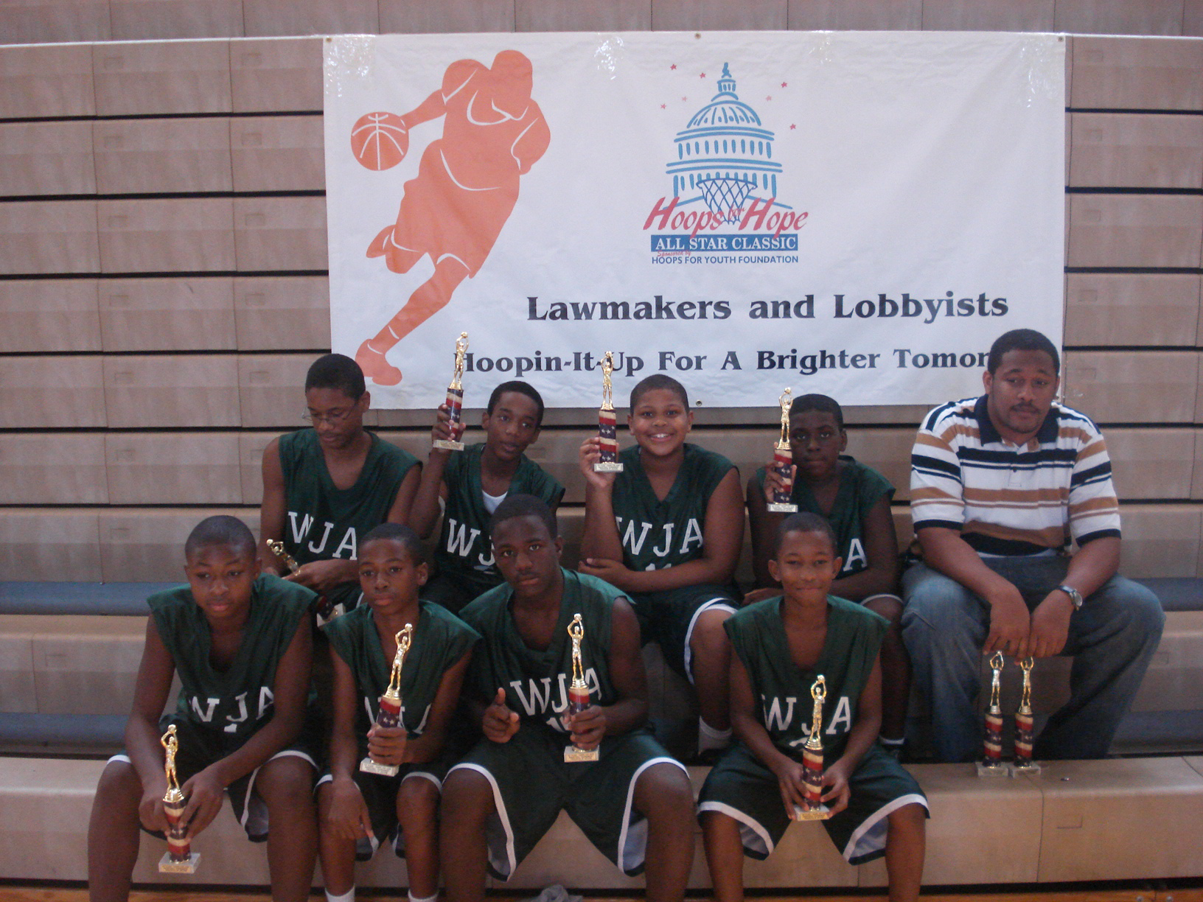
Washington Jesuit Academy

WJA’s Mission is to educate academically talented adolescent boys from low-income families, regardless of religious denomination, providing for them a disciplined, rigorous learning environment.
The Goal of the Education is to prepare these boys to become "men for others" who, having gained confidence spiritually, intellectually, emotionally and physically will be able to succeed in a college preparatory high school on their way to becoming leaders in their communities.

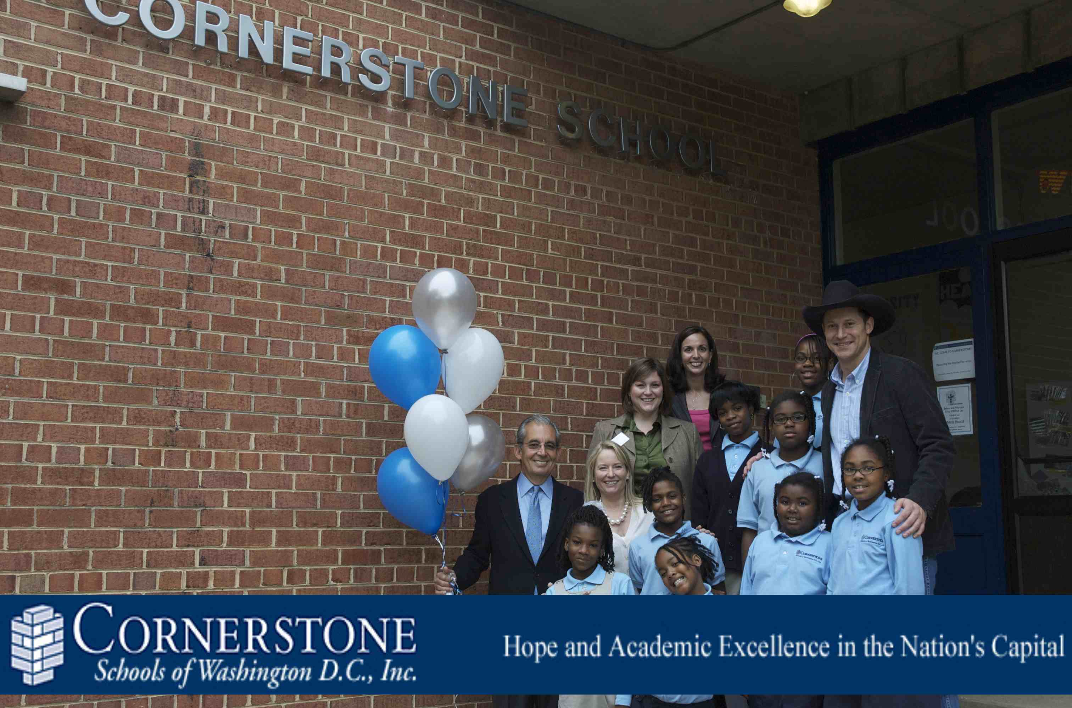
Cornerstone School of Washington, DC
Cornerstone provides an academically rigorous education founded on a Christian world view, in a manner that fosters a lifelong love of learning. Cornerstone fosters a student culture of mutual respect in which moral character is developed based on Biblical principles. Cornerstone equips students to participate in and transform the society in which they live. Cornerstone seeks to represent and be economically accessible to the community it serves, with its racial, economic, and social diversity. Cornerstone recognizes the primary responsibility of parents in the educational process and seeks to partner with them to provide the best education possible. Cornerstone seeks to foster a sense of community among parents, staff, students, volunteers and participating partners and churches.

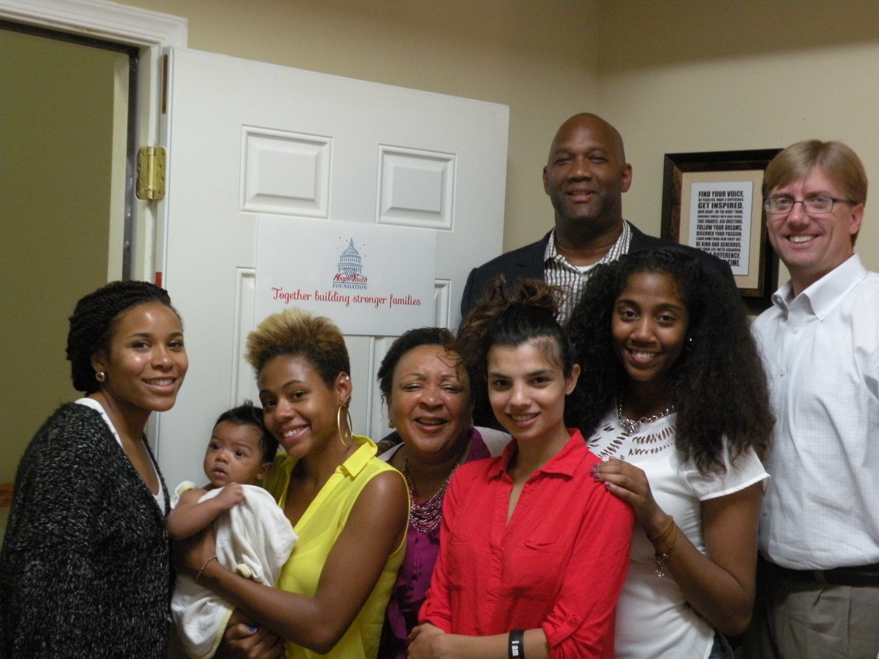
Healthy Babies Project

Healthy Babies Project, Inc. (HBP) is a private, not-for-profit, community-based support organization for District of Columbia pregnant and parenting women and families.

Mission: To help at-risk D.C. families have healthy babies and move out of the cycle of poverty.

How: HBP reaches out to high-risk, low-income, substance-abusing, pregnant and parenting women, men, and their families. They remove barriers to health and success by helping clients identify what they need. They work with service provider partners to connect women and families to resources including health care, housing, nutrition, mental health services, educational support, skills building, substance abuse support, and employment. They stay with clients long-term to give them the best chance for success

HBP Goals: They work with at-risk D.C. women and families to:
- Reduce infant mortality and low birth weight rates.
- Improve D.C. infant health and reduce the incidence of child abuse and neglect.
- Prevent unplanned repeat pregnancies.
- Increase the number of fathers who participate in parenting.

- Provide structured health, prenatal, parenting, and childbirth education.
- Provide safe haven shelter.

HBP values embody where they are as an organization, how we perform our work, and conduct ourselves.

